**Skyline Batch**  
  
Skyline Batch is a user-friendly tool to run a simple Skyline workflow on many files at a time. When run, it uses an invisible instance of Skyline to do the following:

Copy a specified Skyline template file

Import data into this new file

Refine the file to create a new template document

Export reports using the imported data

Run R scripts on these reports

**STARTUP**  
  
Skyline Batch requires an installation of Skyline (or Skyline-Daily).

On startup, you will see the main window:

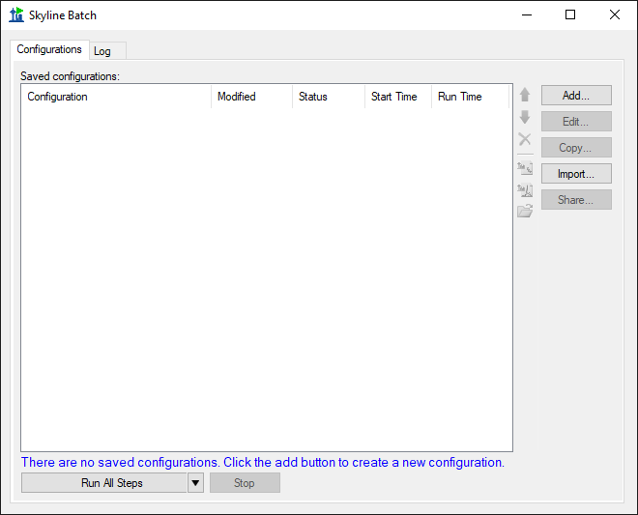

To start using Skyline Batch, create a new configuration by clicking the **Add** button.

This brings up the **Skyline Batch Configuration** form.

**CONFIGURATION Files**

In the **Skyline Batch Configuration** form enter the appropriate settings in the **Files** tab.

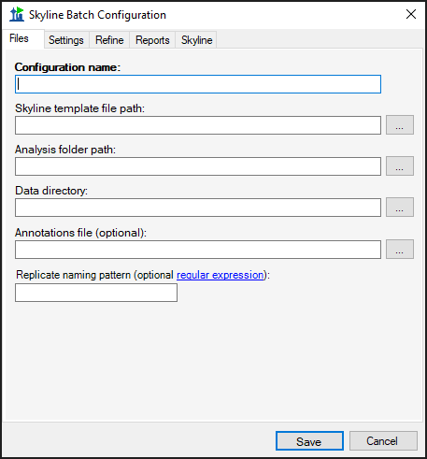

**Configuration name**: This can be the name of the project or study for which data is being acquired. Must be unique.

**Skyline template file path**: This is the path to the template Skyline document that will be copied to the analysis folder and used to import data into.

If you have other configurations that create refined template files, an arrow will appear on the right side of the template file input, allowing you to either select from these files or choose another template.

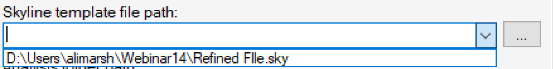

**Analysis folder path**: The path to the local folder in which the copied template document and exported reports will be stored. For Skyline Batch to find the assay library for the template file, the anal

**Data directory**: The folder containing data to import into the copied template document

**Annotations file** (optional): A csv file containing the annotations for the imported data.

**Replicate naming pattern** (optional): A regular expression from which the first group will be used to name replicates when importing.

*Note: For Skyline Batch to find the assay library, the Skyline template file must be in the parent hierarchy of the analysis folder. (ie: If my Analysis folder is “C:\Users\myaccount\Documents\Analysis”, then my template file must be in “users,” “myaccount,” or “Documents”)

**CONFIGURATION Settings**

In the **Settings** tab, various changes to the Skyline document can be specified.

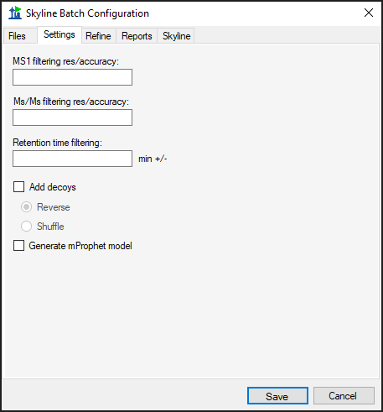

**MS1 filtering res/accuracy** (optional): Resolving power of the precursor mass analyzer. If the mass analyzer is 'Centroided' the value is in PPM.

**Ms/Ms filtering res/accuracy** (optional): Resolving power of the product mass analyzer. If the mass analyzer is 'Centroided' the value is in PPM.

**Retention time filtering** (optional): The number of minutes on either side of the predicted time or MS/MS IDs, i.e. ± minutes.

**Add decoys**: Add decoys to the template document for reintegrate model generation with mProphet. Added decoys are shuffled or reversed based on selection.

**Generate mProphet model**: causes a new model to be created, using the mProphet algorithm with all available scores for the results found in the document. Existing manually integrated peaks will be overwritten with peaks chosen by the reintegration model.

**Configuration refine**

In the **Refine** tab, a new refined Skyline file can be created using the imported data.

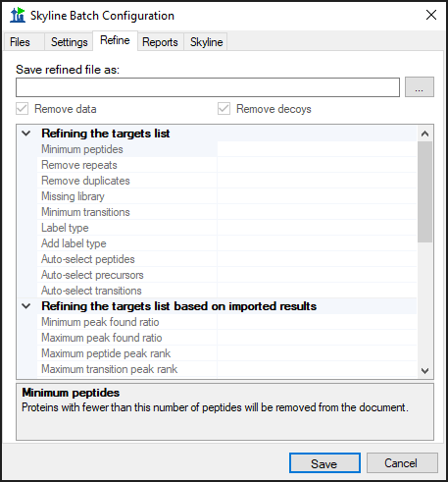

**Save refined file as**: The file path for the new refined file. This is required for any refinement to occur, and the rest of the **Refine** tab will be disabled until this field is filled.

*Note: All the refine commands are performed on the refined file and will not change the results file in the analysis folder.

**Remove data**: If data should be removed from the refined file.

**Remove decoys**: If decoys should be removed from the refined file.

The descriptions for each of the commands in the grid can be found by clicking on the name of the command.

To enter a value for a command, click on the empty space next to its name. A list of options will appear, or you can type other input.

**CONFIGURATION REPORTS**

In the **Reports** tab, a list of reports can be created. If no reports are included for a configuration, Skyline Batch will not export reports or run R scripts for that configuration.

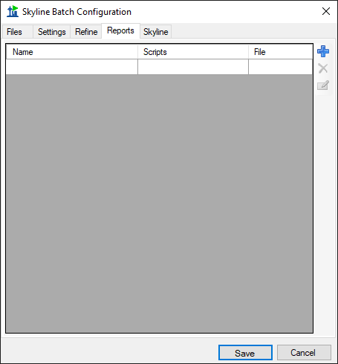

To add a report, click the blue **+** icon on the right and fill in the appropriate information.

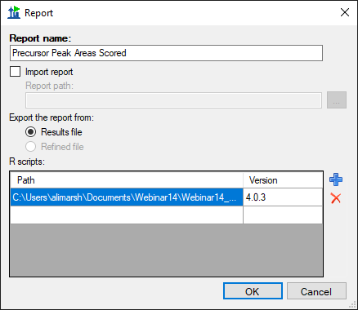

**Report name**: The name of the report to be exported. This MUST correspond to the name of the report when used in Skyline, which may differ from the file name. To find the name of a report:

If you are importing the report from a Skyline report file (.skyr), open the file in Notepad and look for: *name="*report name here"

If you are using a report already imported in your Skyline template document,

open the document and go to View > Document Grid > Reports to see a list of all the report names.

**Import report**: If the report does not exist in your Skyline template document, and needs to be imported from a Skyline report file.

**Report path**: The path to the Skyline report file.

**Export the report from**: Whether to export this report from the results file or the refined file. The refined file option will be grayed out if this configuration does not do refinement.

**R scripts**: The list of R scripts to run on this report after it has been exported to a csv file.

Add an R script by clicking on the blue **+** icon.

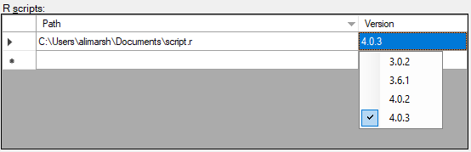

Skyline Batch defaults to running all R scripts on the most recent version of R found on the computer. If you want to specify a different version, click in the **Version** cell of the table to see a drop-down menu of all installed R versions, then click the desired version.

Click **OK** to add the report

**SKYLINE SETTINGS**

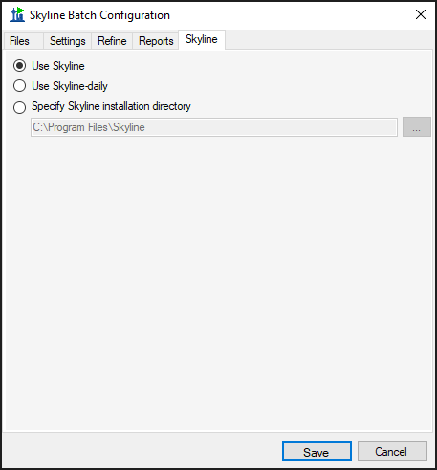

In the **Skyline** tab of the **Skyline Batch Configuration** form, you can specify which installation of Skyline this configuration will use when run. If you do not have an administrative or web-based installation of Skyline or Skyline-daily, the corresponding option will be grayed out. You can always specify a path to a Skyline (or Skyline-daily) installation somewhere else on your computer.

*Note: The Skyline tab does not appear in administrative installations of Skyline Batch. If this is the case, Skyline Batch will use the version of Skyline it was installed with. If you would like to use a different Skyline installation, download the web-based version of Skyline Batch here: <https://skyline.gs.washington.edu/software/SkylineBatch/index.html>

**SHARING CONFIGURATIONS**

To save some or all of your existing configurations to a Skyline Batch configuration file (.bcfg), click the **Share…** button in the main window.

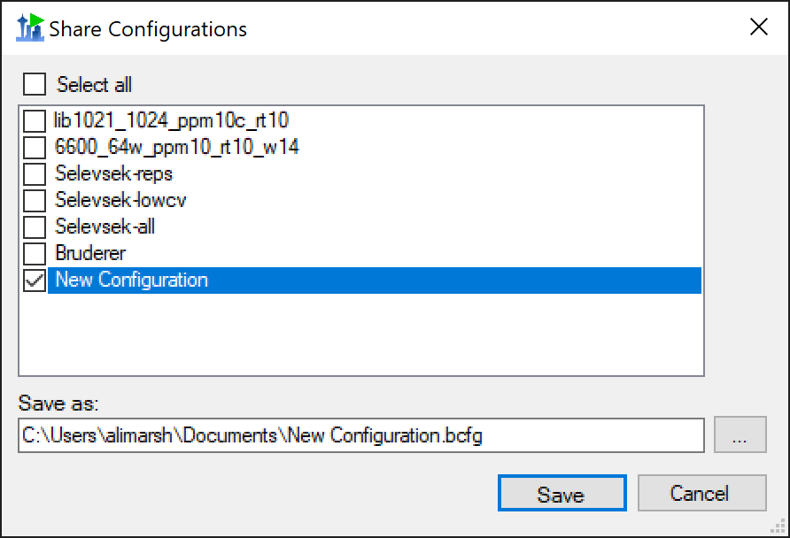

In the Share Configurations Form, you can select configurations you wish to save and specify a file path. Then click **Save**.

The configurations in the resulting file can be imported using the **Import…**  button, or by double-clicking on a Skyline Batch configuration file in File Explorer.

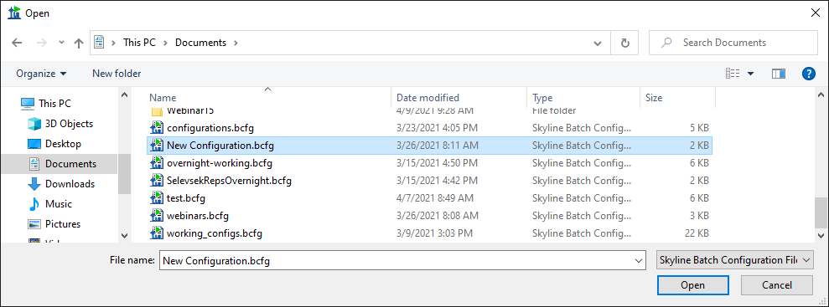

**INVALID CONFIGURATIONS**

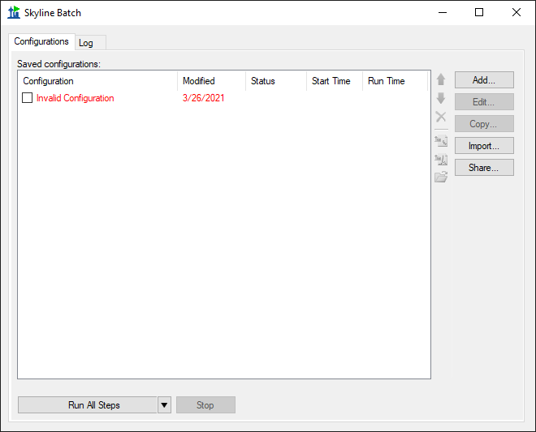

Invalid configurations may occur if files in the configuration do not exist, the configuration uses a version of R not found on your computer, or the Skyline version was not found. They will appear in red, and cannot be run until they have been corrected. When you **Edit** an invalid configuration, the **Configuration Set Up Manager** will guide you through the process of fixing it.

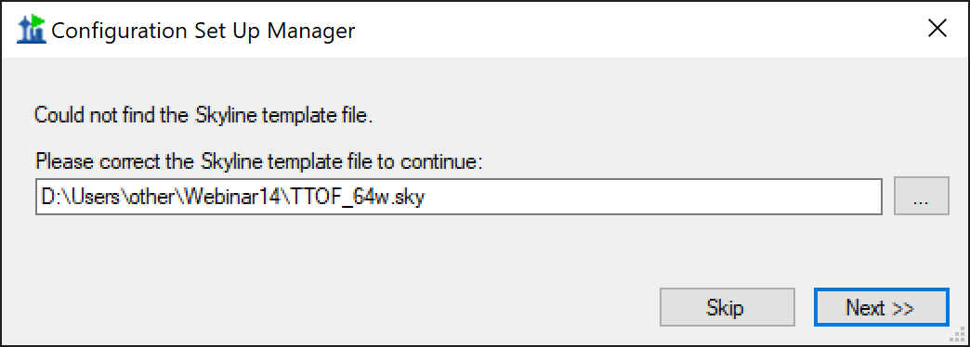

**RUNNING CONFIGURATIONS**

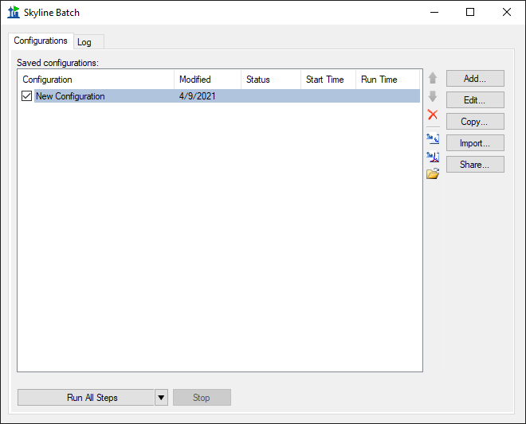

To run a configuration, check the checkbox next to it, then click the **Run All Steps** button.

The **Run All Steps** button will run every checkedconfiguration in the list from top to bottom. The downward-facing triangle on the righthand side of the **Run All Steps** button enables the user to start from a later step when running the configurations.

The **Run from step** options depend on the configurations checked:

At least one configuration with a **refined** No configurations with a **refined output**

**output file** is checked: **file** are checked:

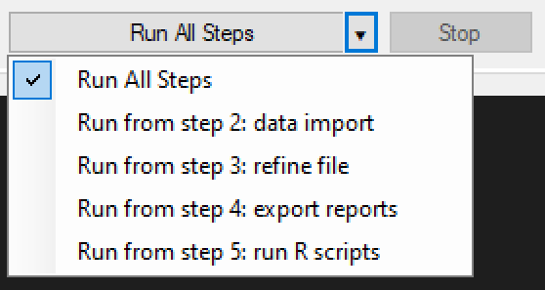 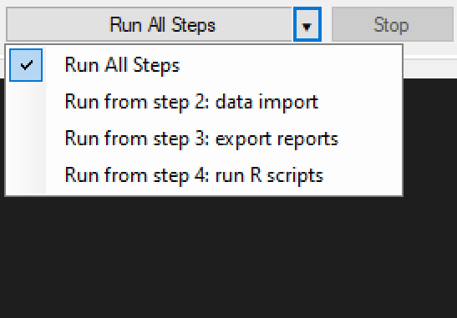

When the **Run All Steps** button or a **Run from step** option is clicked, the program switches to the **Log** tab to display the progress of the current run. Returning to the **Configurations** tab, the status of all configurations is displayed, and will show if they are Running, Waiting, Finished, Canceled, or had an Error. Stop the configurations from running by clicking the **Stop** button. If any configurations are running when Skyline Batch is closed, they will be canceled.

**LOGGING**

This is the view of the **Log** tab after the configurations have started running.

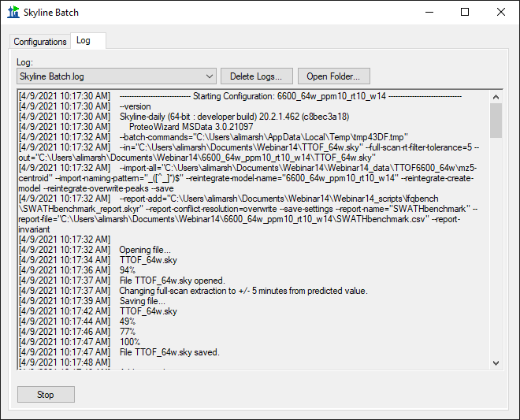

The log will display all output from running the configurations, including which configuration is currently running, what step it is on, and the progress of that step.

Logs of previous runs can be viewed by clicking the **Log** dropdown menu. Previous logs can be managed with the **Delete Logs** button and the folder containing the saved logs can be opened with the **Open Folder** button.

**ACCESSING RESULTS**

A configuration has finished running when it’s status no longer says “Running” and a Run Time is shown.

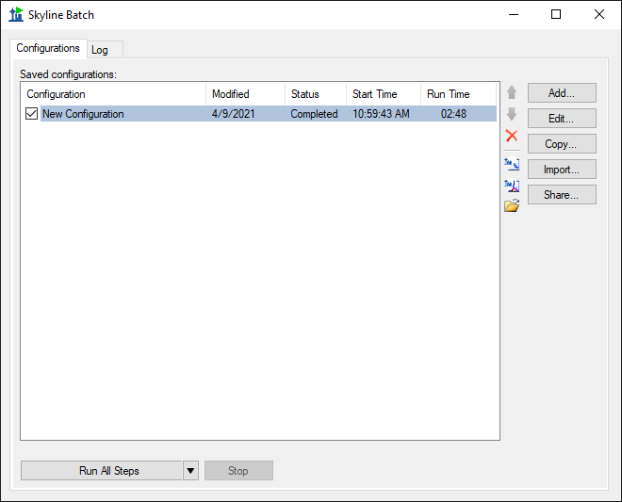

To view results and associated files, select the configuration and click one of these icons:

Opens the Skyline template document



 Opens the Skyline results document

 Opens the analysis folder